Jazz

Chants

1 Sh! Sh! Baby’s sleeping!
I said Sh! Sh! Baby’s sleeping!
I said Sh! Sh! Baby’s sleeping!
What did you say?
What did you say?
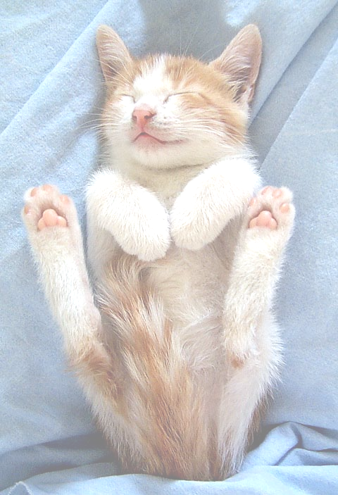
I said Hush! Hush! Baby’s sleeping!
I said Hush! Hush! Baby’s sleeping!
What did you say?
What did you say?
I said Please, be quiet! Baby’s sleeping!
I said Please, be quiet! Baby’s sleeping!
What did you say?
What did you say?
I said Shut up! Shut up! Baby’s sleeping!
Waaaaaaaaaaaaaaaaaaaaaaa
Not any more…

2 Big Mouth John Brown
Who did you see?
I saw John.
John who?
John Brown.
I can’t hear you!
I said John Brown!
I can’t hear you!
I said John Brown!
I can’t hear you!
I said John Brown!
I said John Brown!
John Brown!
John Brown!
What did he say?
Who?
John Brown
John Brown?
Yes, what did he say?
He didn’t say anything.
Nothing?
Not a word.
I don’t believe it
I don’t believe it
Big mouth John Brown didn’t say a word?
Big mouth John Brown didn’t say a word?

3 Rain
It was raining, raining, raining hard
It was falling on my head
It was falling on the stars
It was falling on the sun
It was falling on my shoes
I got soaking wet
I got soaking wet
But I stayed outside
I stayed outside
The rain was sweet
The rain was warm
The rain was soft
It reminded me of home
It was raining, raining, raining hard
It was falling, falling, falling on the stars
It was raining, raining, raining hard
It was falling, falling, falling on the stars
Soft rain

Raining, raining

Sweet rain

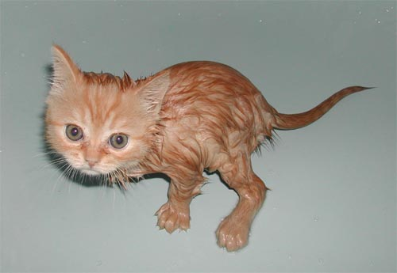
Raining, raining

Warm rain

Raining, raining

Sweet soft
Warm rain
Sweet soft

Warm rain

4 Sally speaks Spanish but not very well
Sally speaks Spanish but not very well
When she tries to speak Spanish,
You really can’t tell
What language she’s speaking
Or trying to speak
The first time I heard her
I thought it was Greek!

How’s his English?
His English is wonderful
He speaks very well
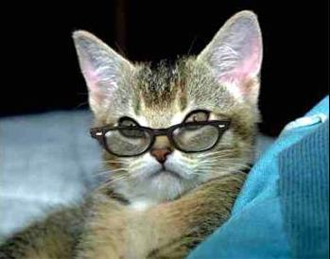
His accent is perfect
You really can’t tell
That he isn’t a native
Of the USA
There’s only one problem
He has nothing to say.

5 It’s got to be somewhere
Where is it? Where is it?
I can’t find it!
She can’t find it!
It’s got to be here, it’s got to be here!
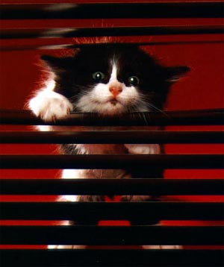
It has to be here! It must be here!
It’s gone! It’s gone!
Take it easy! Take it easy!
It has to be here,
It must be here!
It can’t be lost,
It can’t be lost.
It’s got to be here .
Try to remember!
I can’t remember!
Try to remember!
I can’t remember!
Think back!
I can’t think!
Think back, think back
Where did you put it?
I can’t remember!
Oh, here it is, here it is!
Thank heavens, thank heavens!
I found it!
She found it!
Here it is! Here it is!
Whew!

6 Tall trees
Tall trees, tall trees,
Big tall trees!
Big trees, tall trees
Big tall trees!
The coast of California
Is a beautiful sight
With the tall trees, tall trees,
Big tall trees!
The coast of California
Is a beautiful sight
With the tall trees, tall trees,
Big tall trees!
Big trees, tall trees,
Big trees, tall trees,
Big tall trees!

7 Selfish
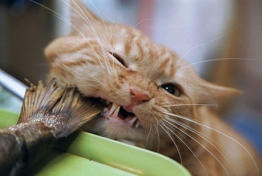
This is mine! That’s yours!
Don’t touch mine!
Get your own!
Hey, what are you doing?
What are you doing with that?
That’s mine!
Hey, what are you doing?
What are you doing with that?
That’s his!
Hey, what are you doing?
What are you doing with that?
That’s hers!
What’s mine is mine!
What’s yours is yours!
What’s his is his!
What’s hers is hers!
What’s ours is ours!
What’s theirs is theirs!

8 What are you going to do at two?
What are you going to do at two?
What are you going to do?
What are you going to do?
Where are you going to be at three?
Where are you going to be?
Where are you going to be?
Who are you going to see?
What are you going to say?
How are you going to go?
Where are you going to stay?
What are you going to do?
Who are you going to see?
When are you going to leave?
Where are you going to be?

Meet me in the morning
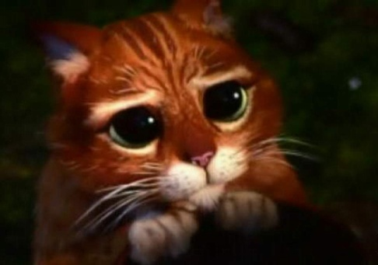
Meet me in the morning.
Meet me at noon,
Meet me in September
or the middle of June.
Meet me at midnight,
Meet me in the hall,
Meet me in the summer,
Meet me in the fall,
Meet me in the evening,
Meet me at eight.
I’ll meet you anytime you want,
But please, don’t be late.

9 Taking credit
Whose book is this?

It’s mine, it’s mine!

Are you sure it’s not his?
No, no it’s mine!
Whose work is this,
This beautiful work?
It’s mine, it’s mine, it’s mine, it’s mine!
Whose work is this,
This awful work?
It’s his, it’s his, it’s his, it’s his!
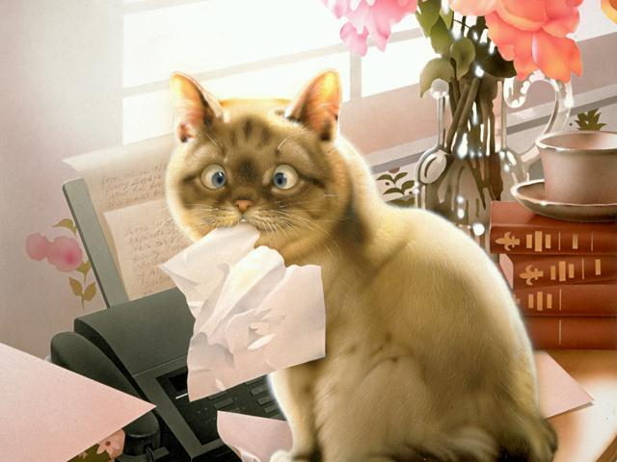
Are you sure it’s not yours?
Of course, it’s not mine,
It’s certainly not mine!
Not mine, not mine!
Not yours?

Not mine!

Are you sure?
I’m sure!
It’s his, it’s his!
Not yours?

Not mine!

10 A bad day
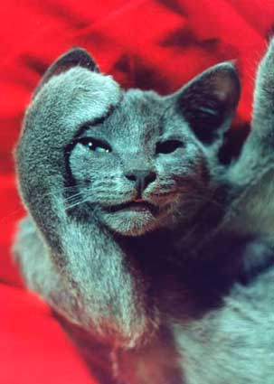
I overslept and missed my train,
Slipped on the sidewalk
In the pouring rain.
Sprained my ankle,
Skinned my knee,
Broke my glasses,
Lost my keys.
Got stuck in the elevator
It wouldn’t go
Kicked it twice and stubbed my toe.
Bought a pen that didn’t write,
Took it back and had a fight.
Went home angry locked the door,
Crawled into bed
Couldn’t take any more.

More bad luck
The bread was stale,
It was four day old.
The milk was sour,
The coffee was сold.
The butter was rancid,
The steak was tough.
The service was dreadful,
The waiter was rough.
My bill was huge,
His tip was small.
I’m sorry I went to that place at all!

11 Personal questions
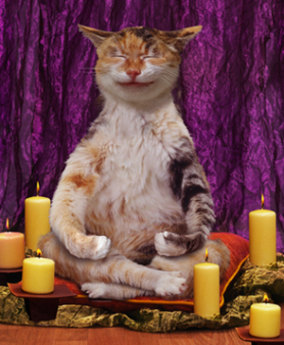
Where were you born?
I’d rather not say.
Where are you from?
I’d rather not say.
How tall are you?
How old are you?
How much do you weigh?
I’d rather not say.
How much rent do you pay?
I’d rather not say.
How much do you make?
I’d rather not say.
Why aren’t you married?
I’d rather not say.
Why don’t have children?
I’d rather not say.
Where were you last night?
Why weren’t you home?
Did you stay out late?
Did you come home alone?
Did you have a good time?
Did you see a good play?
Did you go to a concert?
I’d rather not say.

12 Do you know Mary?
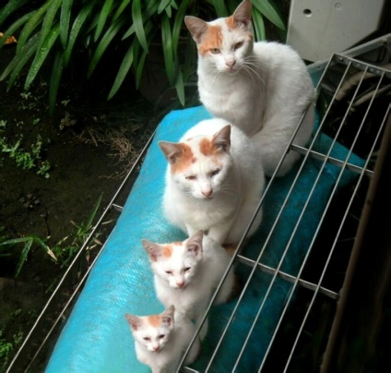
Do you know Mary?
Mary who?
Mary Mc Donald.
Of course, I do.
Do you know her little brother?
Yes, of course, I do.
I know her brother, I know her mother,
and her father too.
Do you know her older sister?
Yes, of course I do.
I know her older sister Betty
and her younger sister Sue.
Do you know her aunt Esther?
Yes, of course, I do.
I know her aunt and her uncles
and her cousins too.
Do you know her husband Bobby?
Yes, of course, I do.
I know her husband and his brother
and his father too.

13 Departure
Have a wonderful trip!
Don’t forget to call me
When you get back.
Have a wonderful trip!
Don’t forget to call me
When you get back.
Have a wonderful trip!
Don’t worry I will.
Don’t forget to call me.
Don’t worry I won’t.
Don’t forget to call me.
Don’t worry I won’t.

Return

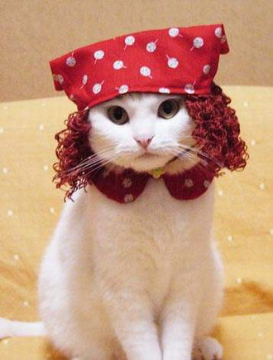
Gee, it’s good to see you!
You look wonderful!
So do you.
It’s been a long time
It sure has.
It’s been a long time
It sure has.
I missed you terribly.
Me too.
I’m so glad you’re back.
So am I.

14 On a diet
First she gave up smoking.
Then she gave up gin.
Then she gave up chocolate cake.
She wanted to be thin.
Then she gave up breakfast.
Then she gave up lunch.
On lazy Sunday mornings
She even gave up brunch.
No matter what she gave up
Her skirts were very tight
Cause she ate twelve cans of tuna fish
for dinner every night.

15 Twelve cans of tuna fish
Twelve cans!
Twelve cans of tuna fish!
Twelve cans!

How many cans?

TWELVE! TWELVE!

Did you say twelve?

Yes, I said twelve!

Twelve cans of what?
Twelve cans of fish.

Twelve cans of fish?
Yes fish, yes fish.

What kind of fish?
Tuna, tuna.

Twelve cans of tuna fish?
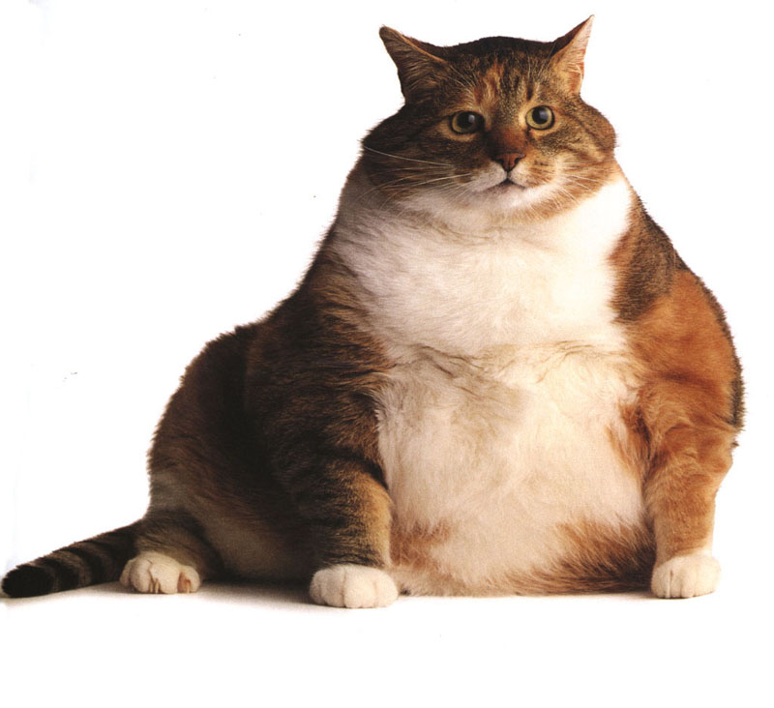
Yes, twelve cans.
Oh, my goodness!
No wonder she’s fat!
How often does she eat
those twelve cans of tuna?
How often does she eat
those twelve big cans?
Every night, every night!
She eats twelve cans of tuna fish
every night.
You’re kidding!
Oh, my goodness!
No wonder she’s fat!
That’s a lot of tuna.
It sure is!
That’s too much tuna, if you ask me.
It sure is! It sure is!
Twelve cans of tuna is a lot of fish
If you ask me, if you ask me.
It sure is! It sure is!

16 Panic on being late
What time is it? What time is it?
Hurry up! Hurry up! Hurry up! Hurry up!
What time is it? What time is it?
Please, hurry up!
We’re going to be late!
Oh, I don’t have time
To talk to you now.
I’m late, I’m late, I’m terribly late!
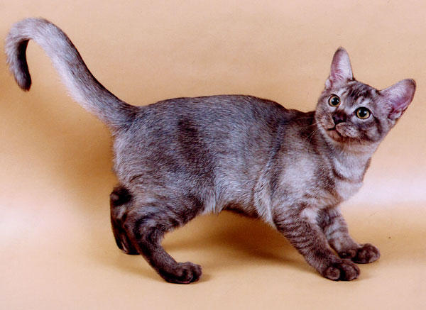
Hurry up! Hurry up!
What time is it?
Hurry up! Hurry up!
What time is it?
Hurry up!

17 Ouch! That hurts
Ouch!
What’s the matter?
I stubbed my toe.
Oh, that hurts, that hurts
I know that hurts.
Ouch!
What’s the matter?
I bit my tongue.
Oh, that hurts, that hurts
I know that hurts.
Ouch!
What’s the matter?
I got a cramp in my foot.
Oh, that hurts, that hurts
I know that hurts.
Ouch! Ouch!
What’s the matter now?
I bumped into the table
Tripped on the stairs
Slipped on the carpet
Fell over the chairs.
Gee! You’re clumsy today!

18 Would you walk to China if you had the time?
Would you walk to China if you had the time?
Would you leave at a quarter to three?
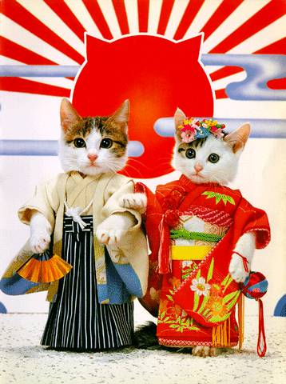
Would you walk to China if you had the time?
Would you walk to China with me?
Of course, I’d walk to China if I had the time.
I’d leave at a quarter to three.
Of course, I’d walk to China tomorrow night
If I were only free.
Why can’t you walk to China tomorrow night?
Why can’t you go to China at three?
Why can’t you walk out on your sweet sugar cat
And sail to China with me?
Well, I have to stay home and take care of my plants,
Take care of my darling too.
And I’d never walk out on my sweet sugar cat
And go to China with you.

19 Major decisions
How do you like your coffee?
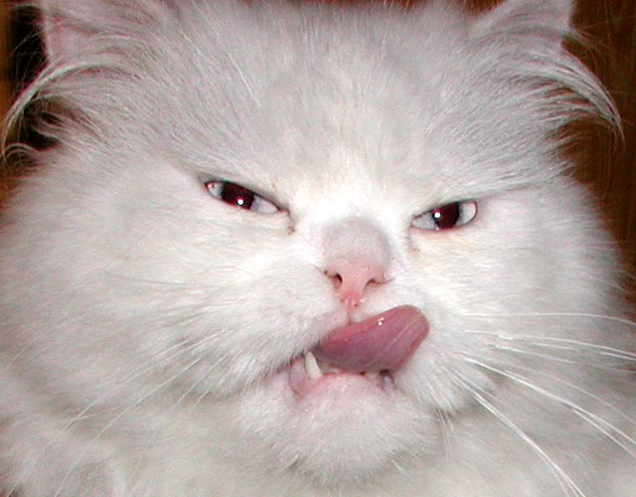
Black! Black!
How do you like your tea?
With lemon, please!
How do you like your steak?
Medium rare.
How do you like your eggs?
I don’t care!
Sunny-side up?
I don’t care!
Poached on toast?
I don’t care!
Scrambled, with bacon?
I don’t care!
Over-easy?
I don’t care!
Soft-boiled? Hard-boiled?
I don’t care!
What about an omelet?
I don’t care!
Come on, tell me!
This isn’t fair!
I told you the truth
I really don’t care!

21 Banker’s wife’s blues
Where does John live?
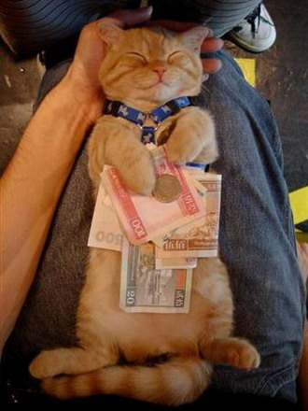
He lives near the bank.
Where does he work?
He works at the bank.
When does he work?
He works all day
And he works all night
At the bank, at the bank
At the great, big bank.
Where does he study?
He studies at the bank.
Where does he sleep?
He sleeps at the bank.
Why does he spend all day, all night,
All day, all night
At the bank, at the bank?
Because he loves his bank
More than his wife
And he loves his money
More than his life.

22 Tell me your name
Tell me your name, again, please.
Tell me your name.
Tell me your first name.
Tell me your last name.
Spell your name for me please.
Pronouns your name for me please.
Say it again.
What a beautiful name!
What a lovely name!

Sand
If I were home, if I were home,
I’d run to the beach, take off my shoes
And walk in the sand.
I’d shake the sand out of my shoes.
I’d feel it between my toes.
I’d smell wet sand in my hair.
I’d feel it in my eyes.
My face would sparkle from the sand.
I would say “I hate this sand”
Back home the bed would be full of sand.
And my clothes, and my hair.
I would wake up and feel the sand in my hair.
Oh, it’s been so long
Since I have felt sand in my hair.

23 Late again
Are you ready?
Are you ready to go?
Not quite, not quite
Just a minute, don’t rush me!
Hurry up! Hurry up!

I’ll be ready in a minute,
in a minute, in a minute.
I can’t find my keys!
Come on, let’s go!
I can’t find my socks!
Come on, let’s go!
Let’s go! Let’s go!
I can’t find my shoes!
Come on, let’s go!
Let’s go! Let’s go!
Your keys are in your hand.
Your socks are in your shoes.
Your shoes are on the floor.
Let’s go! Let’s go!

24 Warning
Watch out! Watch out!
There is a hole in the floor!
What?
A hole.

Where?
In the floor.
A hole in the floor?
Well, I don’t see any hole in the floor.
I don’t see any hole.
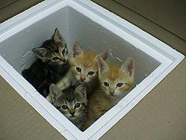
It’s there!
Where?
Right there!
Right here?
Yes, right there.
Are you sure?
Sure, I’m sure.
It’s big as a house.
Big?
It’s huge.
Huge?
It’s huge.
A huge hole, a great big hole
A great big hole in the floor.
I think you’re kidding, you’re teasing me.
There’s no hole in the……..

25 Friends
Well, I’ve known Jack for fourteen years.
He’s a pretty good friend of mine.
She’s known Bill for fourteen years.
He’s a pretty good friend of hers.
And I’ve known Bill for thirteen years.
He’s a pretty good friend of mine.
She’s known Bill for thirteen years.
He’s a pretty good friend of hers.
I’ve known them both for quite a long time.
They’re pretty good friends of mine.
She’s known them both for quite a long time.
They’re pretty good friends of hers.
I’ve known Jim for a long time.
He’s an old, old friend of mine.
She’s known Jim for a long time.
He’s an old, old friend of hers.
We’re old friends, old friends.
He’s a dear, old friend of mine.
How long have you known your old friend Sue?
How long have you known dear Claude and Sue?
Well, I met them just before I met you.
They’re my closest friends, dear Claude and Sue.

26 Easy solutions
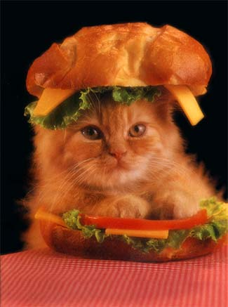
Gee, I’m hungry!
Have a sandwich.
Gee, I’m angry!
Calm down.
Gee, I’m sleepy!
Take a nap.
Gee, it’s chilly in here.
Put on a sweater.
Gee, it’s hot in here!
Open a window.
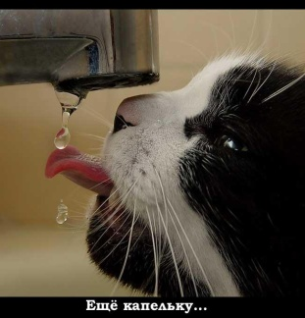
I’ve got the hiccups.
Drink some water.
My nose itches.
Scratch it.
My feet hurt!
Sit down for a while.
My shoes are tight!
Take them off.
I have a toothache!
Go to the dentist.
I have a headache!
Take some aspirin.
I’m lonely!
Call up a friend.
I’m bored.
Go to a movie.

27 Love song
Does she love him?
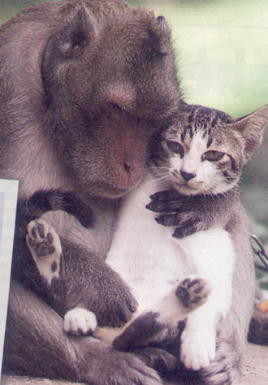
Yes, she does.
Is she happy?
Yes, she is.
Does he know it?
Yes, he does, yes he knows it.
Will she hug him?
Yes, she will.
Will she kiss him?
Yes, she will.
Will she leave him?
Yes, she will, it she has to.
Does he her?
Yes, he does.
Is he happy?
Yes, he is.
Does she know it?
Yes, she does, yes she knows it.
Will he hug her?
Yes, he will.
Will he kiss her?
Yes, he will.
Will he leave her?
Yes, he will, it he has to.
Are they happy?
Yes, they are.
Are they lucky?
Yes, they are.
Do they know it?
Yes, they do, yes, they know it.
Will he find somebody new?
Will she find somebody too?
Yes, they will.
Yes, they will, it they have to.

28 On the rocks
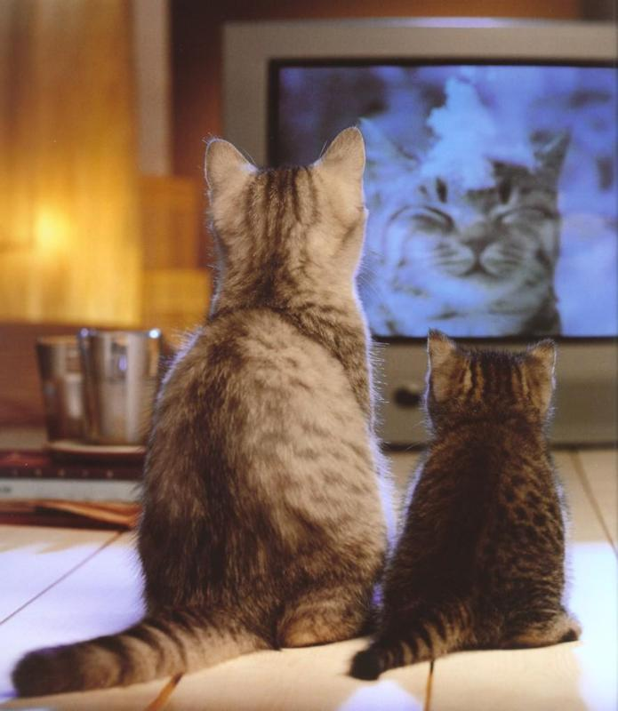
You never listen to me.
What did you say?
You never listen to me.
What?
He never listens to me.
He never talks to me.
He just sits around and watches TV.
She never listens to me.
She never talks to me.
She just sits around and watches TV.
She never listens to me.
She just sits around
She never talks to me.
She just sits around
She just sits around
She just sits around and watches TV.
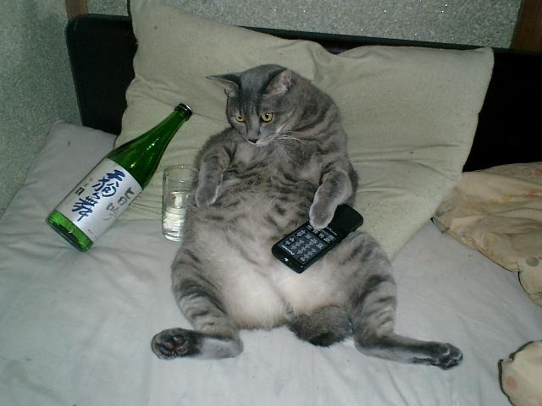
She just sits around.
He never listens to me.
He just sits around
He never talks to me.
He just sits around
He just sits around
He just sits around and watches TV.
He just sits around.

29 The beaches of Mexico
Have you ever seen the beaches of Mexico?
Have you ever walked the streets of San Juan?
Have you ever been to Haiti?
Have you ever been to Spain?
Have you ever walked barefoot
In a heavy rain?
Have you ever been in trouble?
Have you ever been in pain?
Have you ever been in love?
Would you do it all again?
Well, I’ve never seen the beaches of Mexico.
I’ve never walked the streets of San Juan.
I’ve never been to Haiti.
I’ve never been to Spain.
I’ve never walked barefoot
In a heavy rain .
But, I’ve sure been in trouble.
I’ve sure been in pain.
I’ve sure been in love.
I’d do it all again.

30 I’m sorry, but…
I’m sorry, but you’ve got to do better than this.
I’m doing the best I can.
I’m sorry, but you’ve got to walk faster than this.
I’m walking as fast as I can.
I’m sorry, but you’ve got to work harder than this.
I’m working as hard as I can.
It’s not good enough. It’s not good enough.
It’s not good enough. It’s not good enough.
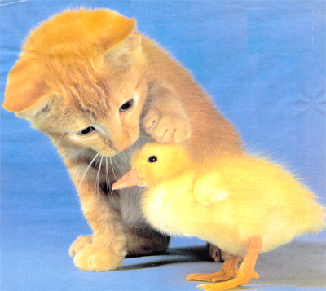
I’m doing my best!
Try a little harder!
I’m doing my best!
Try a little harder!
I can’t, I can’t.
Don’t say: can’t.
I won’t, I won’t.
But I’m doing my best!
Do a little better.
I’m doing my best!
Try a little harder.
I’ll try, I’ll try.
Try a little harder.
I’ll try, I’ll try.

31 Baby Bobby
Betty bought a bright blue blanket
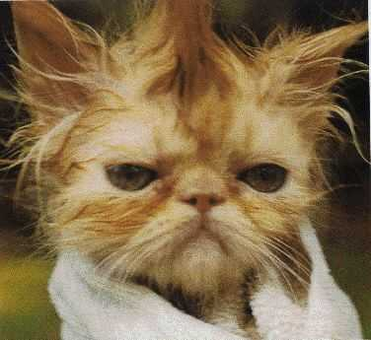
for her baby boy.
He cried when he saw it.
He hates bright blue.
Betty bought a blanket.
Betty bought a blue blanket.
Betty bought a bright blue blanket.
for her baby boy.
He cried when he saw it.
He hates bright blue.
Betty’s baby’s name is Bobby.
Baby Bobby is a bad, bad boy.
Bobby is a bad, bad baby.
He drives everybody crazy.
Bobby is a bad, bad baby.
Baby Bobby is a bad, bad boy.
Bobby broke his mother’s glasses.
Bobby baby! Why did you do that?
Bobby lost his father’s keys.
Bobby baby! Why did you do that?
Bobby threw the paper in the kitchen sink.
Daddy got very, very angry.
He cut all the buttons off his father’s shirt.
Daddy got very, very angry.
Bobby is a bad, bad baby.
Baby Bobby is a bad, bad boy.

32 It’s like winter today
It’s like winter today.
It looks like winter.
It feels like winter.
Close the windows!
Shut the door!
Light the stove!
Hold me!
It’s like spring today.
It looks like spring.
It feels like spring.
Open all the windows!
Open the door!
Turn off the stove!
Hold me!

33 My feet hurt
My feet hurt!
Take off your shoes!
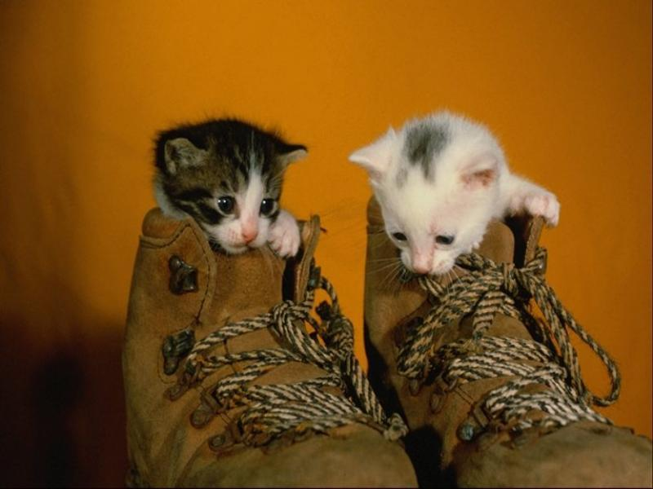
It’s hot in here!
Take off your sweater!
My feet hurt!
Take off your shoes!
It’s cold in here!
Put on your sweater!
My feet hurt!
Take off your shoes!
My hands are cold!
Put on your gloves!
My feet hurt!
Take off your shoes!

34 Mama knows best
You shouldn’t do it that way.
You ought to do it this way.
You ought to do it this way.
You ought to do it my way.
You shouldn’t wear it that way.
You ought to wear it this way.
You ought to wear it this way.
You ought to wear it my way.
You shouldn’t go with them.
You ought to go with us.
You shouldn’t take the train.
You ought to take the bus.
You shouldn’t wear that hat.
You ought to cut your hair.
You shouldn’t get so fat.
You ought to eat a pear.
You shouldn’t do it that way.
You ought to do it this way.
You ought to do it this way.
You ought to do it my way.

35 The Fred poems

Fred gets up at eight o’clock
Fred gets up at eight o’clock.
His cats get up at seven.
His dog wakes up at ten to six.
But his bird sleeps ’till eleven.

Fred gave a party but nobody came
Fred gave a party but nobody came.
Nobody came but his mom.
Fred gave a party but nobody came.
Nobody came but Tom.
Tom left early.
Mom went home.
Fred had to stay at his party alone.

Four fat flies
I wish I could find
those four fat flies
that flew in my window
last Friday night.
Four flies flew in.
Four flies, not three.
One landed on Fred.
Three landed on me.

36 Big Bill Bell
He is here!
Who’s here?
Bill’s here.
Bill who?
Bill Bell.
Bill Bell? Who’s he?
You know him.
I do?
Of course, you do.
He’s a friend of yours.
He is?
Of course, he is.
Big Bill, big Bill Bell!
Oh, you mean Bill!
Big Bill!
That’s right, that’s him.
You know him very well.
Sure I do!
Big Bill Bell!
Big Bill Bell!
I know him very well!

37 Wake up! Wake up!
Wake up! Wake up!
What time is it?
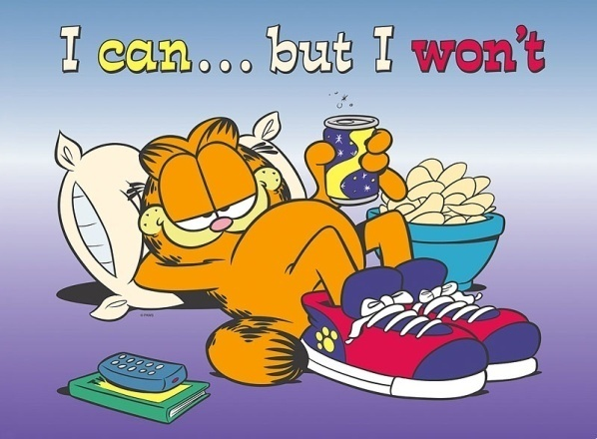
It’s time to get up!
What time is it?
Come on, get up!
I don’t want to get up.
You have to get up!
I don’t want to get up.
You must get up!
I don’t want to get up.
You’ve got to get up!
I don’t want to get up.
Come on, get up!
I don’t want to get up.
Get up! Get up!
You’re going to be late!
Late for what?
Late for work.
Late for work?
It’s Sunday!!

38 Well, he eats like a pig
Well, he eats like a pig.

He can’t get enough.
He works like a dog.
He looks real tough.
He smokes like a chimney,
Four packs a day.
He sleeps like a log.
What more can I say?
He drinks like a fish
Scotch on the rocks.
When he gets real mad
He hardly talks.
He cries like a baby,
When he’s feeling sad.
He’s the dearest friend
I’ve ever had!

39 You’re just like your mother
Stop it!
Stop what?
Stop arguing with me.
I’m not arguing with you.
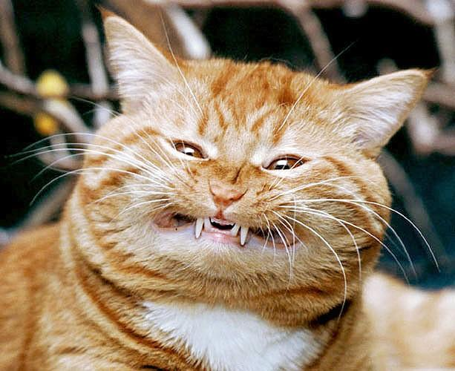
Yes, you are.
No, I’m not.
Yes, you are.
No, I’m not.
You are too.
I am not.
You are too.
I am not.
You’re just like your mother.
I am not.
Yes, you are.
I am not.
Yes, you are.
I am not.
She loves to argue.
No, she doesn’t.
Yes, she does.
No, she doesn’t.
She does too.
She does not.
She does too.
She does not.
Don’t argue with me!

